Name : Sanghrakshit Prakash Waghmare

Roll No. : S512050

Div. : B

Subject : OOP Practical 1

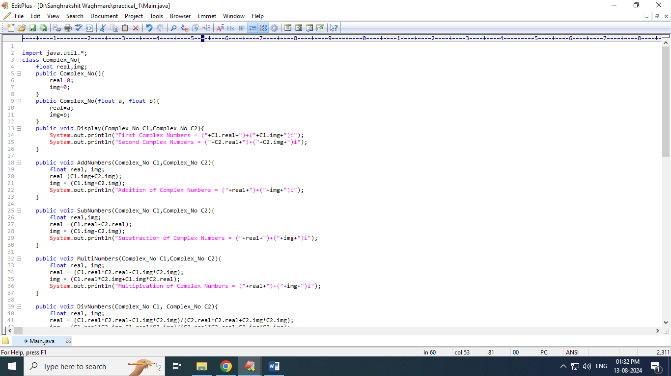

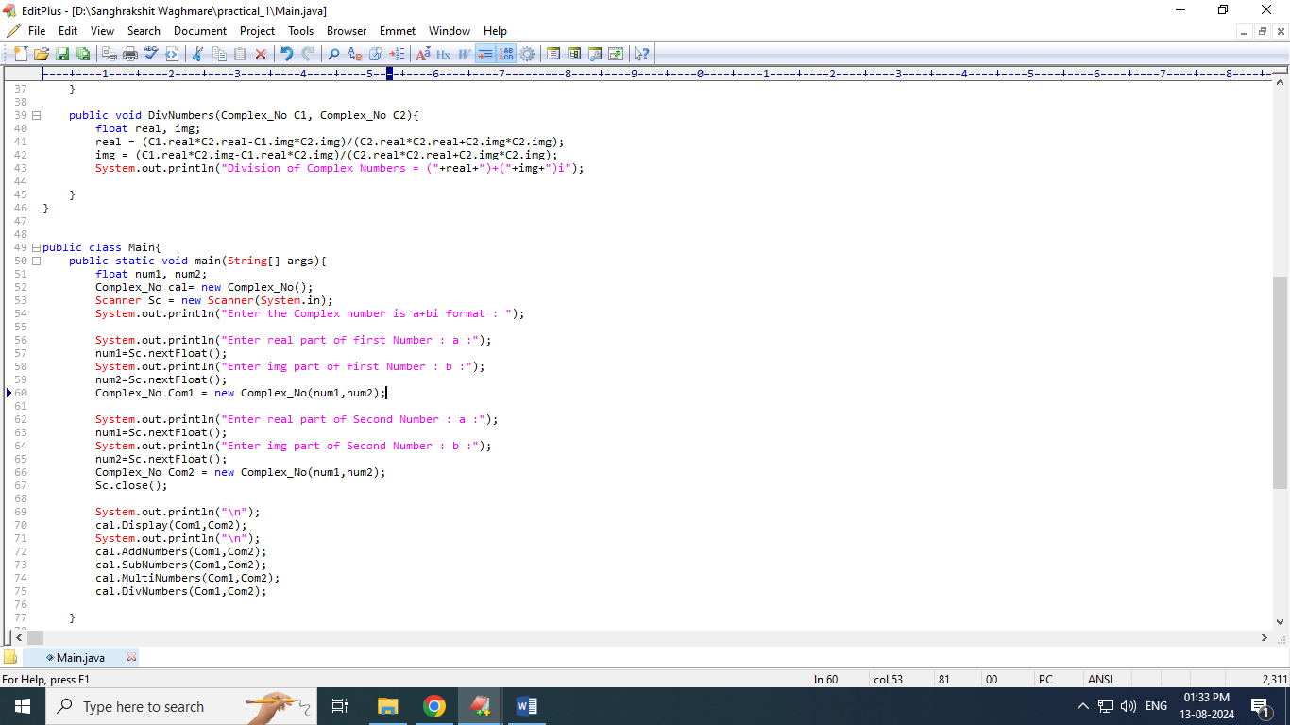

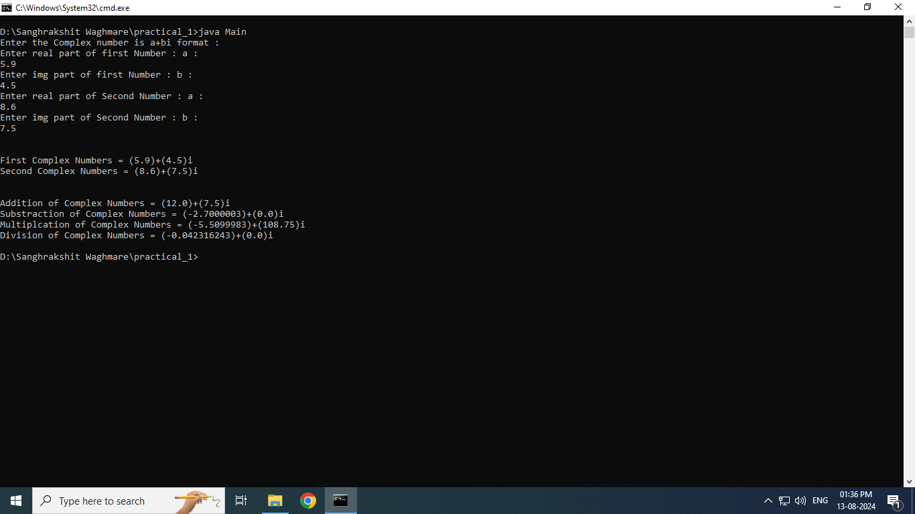

import java.util.*;

class Complex_No{

float real,img;

public Complex_No(){

real=0;

img=0;

}

public Complex_No(float a, float b){

real=a;

img=b;

}

public void Display(Complex_No C1,Complex_No C2){

System.out.println("First Complex Numbers = ("+C1.real+")+("+C1.img+")i");

System.out.println("Second Complex Numbers = ("+C2.real+")+("+C2.img+")i");

}

public void AddNumbers(Complex_No C1,Complex_No C2){

float real, img;

real=(C1.img+C2.img);

img = (C1.img=C2.img);

System.out.println("Addition of Complex Numbers = ("+real+")+("+img+")i");

}

public void SubNumbers(Complex_No C1,Complex_No C2){

float real,img;

real =(C1.real-C2.real);

img = (C1.img-C2.img);

System.out.println("Substraction of Complex Numbers = ("+real+")+("+img+")i");

}

public void MultiNumbers(Complex_No C1,Complex_No C2){

float real, img;

real = (C1.real*C2.real-C1.img*C2.img);

img = (C1.real*C2.img+C1.img*C2.real);

System.out.println("Multiplcation of Complex Numbers = ("+real+")+("+img+")i");

}

public void DivNumbers(Complex_No C1, Complex_No C2){

float real, img;

real = (C1.real*C2.real-C1.img*C2.img)/(C2.real*C2.real+C2.img*C2.img);

img = (C1.real*C2.img-C1.real*C2.img)/(C2.real*C2.real+C2.img*C2.img);

System.out.println("Division of Complex Numbers = ("+real+")+("+img+")i");

}

}

public class Main{

public static void main(String[] args){

float num1, num2;

Complex_No cal= new Complex_No();

Scanner Sc = new Scanner(System.in);

System.out.println("Enter the Complex number is a+bi format : ");

System.out.println("Enter real part of first Number : a :");

num1=Sc.nextFloat();

System.out.println("Enter img part of first Number : b :");

num2=Sc.nextFloat();

Complex_No Com1 = new Complex_No(num1,num2);

System.out.println("Enter real part of Second Number : a :");

num1=Sc.nextFloat();

System.out.println("Enter img part of Second Number : b :");

num2=Sc.nextFloat();

Complex_No Com2 = new Complex_No(num1,num2);

Sc.close();

System.out.println("\n");

cal.Display(Com1,Com2);

System.out.println("\n");

cal.AddNumbers(Com1,Com2);

cal.SubNumbers(Com1,Com2);

cal.MultiNumbers(Com1,Com2);

cal.DivNumbers(Com1,Com2);

}

}